

Deutsche Bank
Global Sentiment Survey on Europe 2026
The world has confidence in Europe. Now Europe must deliver.
A global business view of Europe as an investment destination

Content
Key findings at a glance 3
Methodology 4
Detailed survey findings 5
1 Europe offers a strong investment case 5
2 Confidence in Europe is translating into investment plans 9
3 Turning Europe’s strengths into action 12
4 Germany leads the European field 15
5 Priorities for action in Europe 17
6 Europe has yet to realise the full benefits of the Single Market 18
7 Europe can strengthen its AI competitiveness 21
8 European banks are well placed to support investment 23
Summary: What the results mean for Europe 25

“The global economy has confidence in Europe. That is the key message of our survey, which confirms what we see every day in our business with clients around the world. Business leaders view Europe as an attractive investment destination, a growth market and a hub for innovation. At the same time, the survey shows that Europe still has ground to make up when it comes to competitiveness and business conditions. This is why decisive reforms are now needed to unlock stronger growth and encourage greater investment." Alexander von zur Mühlen, Member of the Management Board of Deutsche Bank

Key findings at a glance
Seen through the eyes of the world's investors, Europe is a story of opportunity. The following findings summarise the survey findings and set the order for the chapters of the report that follows.
- Business leaders put Europe ahead of America and Asia. More than a third of decision-makers (35 percent) name Europe the most attractive region for their business, ahead of APAC (excluding China) and North America.
- Confidence in Europe is growing. For 81 percent, Europe matters more in investment decisions today than three years ago – 28 percent say it is much more important, 53 percent somewhat more important – and only 3 percent see it declining.
- Europe is seen as resilient in uncertain times. Some 71 percent rate Europe as highly or rather resilient amid economic and geopolitical stress, rising to 82 percent in the Middle East. Stability has become an important factor in investment decisions.
- Investors are increasingly keen to venture into Europe. 61 percent are already invested and plan to expand within five years, and a further 33 percent plan or are considering market entry. For many, this would mean reallocating capital from other regions.
- Europe remains an attractive consumer market, while its industrial importance continues to grow. 99 percent call Europe an important consumer market and 92 percent say it is important for production, research and development, and supply-chain stability. Europe’s industrial role still has room for growth as only 19 percent of companies already active in Europe currently produce or manufacture goods in the region.
- Europe scores highly on growth and innovation. Its main advantages over other regions are growth opportunities (74 percent) along with its capacity for innovation, particularly in combination with the potential of AI (71 percent), ahead of international relationships (70 percent) and economic and market stability (68 percent).
- Germany is Europe’s investment magnet. Some 56 percent name Germany among their top three European destinations and 29 percent as their first choice, ahead of the United Kingdom and France. Its advantage lies in performing strongly across a broad range of factors.
- Europe’s biggest obstacle is Europe itself. Cross-border friction reduces Europe’s attractiveness for 85 percent to some extent, and four factors – labour cost, tax environment, energy costs, and approval and permitting speed – stay below a 50 percent advantage. Simpler AI rules top investors' wish lists.
- European banks are the preferred partners. 60 percent of respondents would prefer to work with a European bank. Financial strength is the most important factor when selecting a banking partner, closely followed by robust risk and compliance capabilities as well as local market and regulatory expertise.

Methodology
This survey looks at Europe from the outside in. It asks international decision-makers who allocate capital – senior leaders at companies outside Europe that already invest there or plan to – how they see the region.
The Global Sentiment Survey on Europe 2026 was conducted as a business-to-business online survey in July and August 2026 among 1,200 senior decision-makers at companies with 100 or more employees. All participating companies are headquartered outside Europe, across 13 markets in three regions. The sample comprises 600 respondents from APAC – China (including Hong Kong, references to China throughout this report include Hong Kong), Japan, Singapore, India, Australia, South Korea and Taiwan – 400 from the Americas – the US, Canada, Brazil and Mexico – and 200 from the Middle East – the United Arab Emirates and Saudi Arabia.
Respondents were admitted through several screening criteria, so that the survey captures informed, decision-relevant views rather than general opinion. Only senior leaders with genuine strategic or financial responsibility qualified. The decisive filter was Europe experience: only companies that already invest or operate in Europe, or that are planning or actively considering entry within the next five years, were included.
Reading the findings
Within this defined group, the results provide a relevant picture of how internationally active decision-makers view Europe. They should not, however, be read as representative of all companies in the 13 markets surveyed. Three limitations are important:
- The sample is deliberately pre-selected. Respondents were filtered on seniority, size and, above all, on existing or planned engagement in Europe, so the audience is intentionally focused on companies already invested in Europe or those planning to.
- Economic areas are represented by defined markets, not in full. Regional figures describe the surveyed markets rather than an entire continent or economic area.
- Larger companies are over-represented and results are reported unweighted. About 71 percent of respondents come from companies with 500 or more employees.

With these limitations in mind, the data provides a robust picture of how international investors view Europe. Unless stated otherwise, figures relate to all 1,200 respondents. The margin of error for the full sample is approximately plus or minus three percentage points.

Detailed survey findings

Europe offers a strong investment case
Asked as part of this survey how they view Europe as a place to invest, senior leaders describe a region that is widely attractive, growing in importance and valued for its stability. This first chapter sets out the evidence for that confidence.
At a glance
90%  rank Europe among their Top 3 regions | 35%  place Europe as their single most attractive region | 81%  say Europe has become more important over three years

The most broadly favoured region
The starting point is clear. About nine in ten respondents place Europe among their three most attractive regions for investment, ahead of North America at around 69 percent and APAC excluding China at around 56 percent. No other region is named this widely: China (30 percent), the Middle East (32 percent) and Latin America (24 percent) all sit well behind. Europe is the one region that almost everyone rates highly, which makes it a natural anchor for globally diversified investors.
This broad appeal does not come from a single group of investors. It holds across the surveyed regions, with Europe reaching about 90 percent Top-3 recognition among decision-makers in APAC, the Middle East and the Americas alike. The picture also holds across investment stages: companies already invested in Europe place it among their Top 3 slightly more often (92 percent) than those still planning to enter (86 percent).
Figure 1: Attractiveness of regions (Top 3)
Region named under Top 3 (all respondents and investment status)
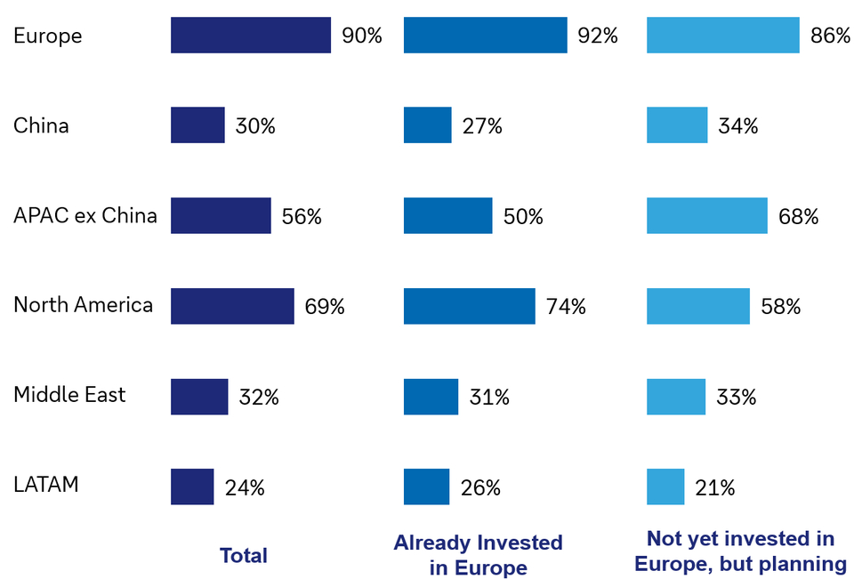

Source: Global Sentiment Survey on Europe 2026, B2B online survey. Base: n = 1,200 (Already invested in Europe 807, Not yet invested in Europe but planning 393)

Experience in Europe deepens conviction
Europe tops the list of global investment destinations for more than a third of respondents. 35 percent place it in first position, ahead of APAC excluding China (24 percent) and North America (19 percent).
Among companies already invested in Europe, the first-choice share rises to 45 percent; among those not yet invested it is 15 percent. This means companies with experience in Europe rank it higher. At the same time, there is clear room to win over those who rate the region highly overall but have not yet made it their first choice.
Figure 2: Attractiveness of regions (Top 1)
Region named as Top 1 (all respondents and investment status)
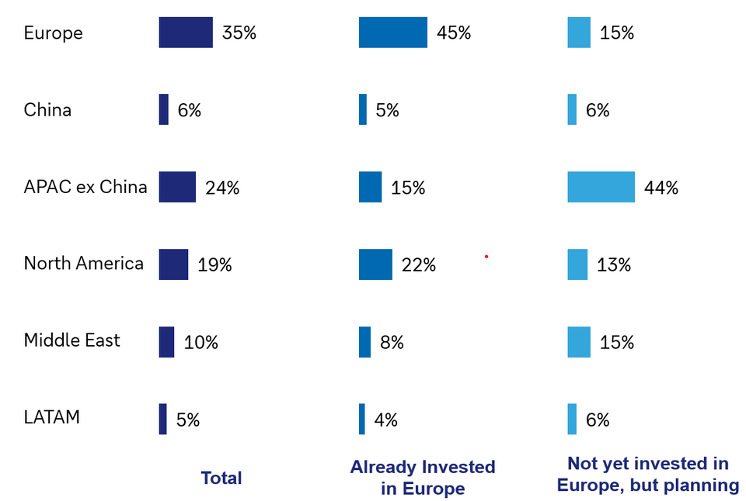

Source: Global Sentiment Survey on Europe 2026, B2B online survey. Base: n = 1,200 (Already invested in Europe 807, Not yet invested in Europe but planning 393)

Growing importance in investment decisions
Europe's attractiveness is growing. 81 percent of respondents say the region has become more important in their investment decisions over the past three years – 28 percent much more important and 53 percent somewhat more important – while only 3 percent say it has become less important.
The rise is broad but not even. It is steepest among American investors, where 39 percent say Europe has become much more important, against 24 percent in APAC and 20 percent in the Middle East. Combining those who say Europe has become much more or somewhat more important, the share reaches 89 percent in the Middle East and 85 percent in the Americas, with APAC a little behind at 77 percent.

Figure 3: Importance of Europe vs. 3 years ago, by region
Top-2 Box of five-point scale (all respondents)
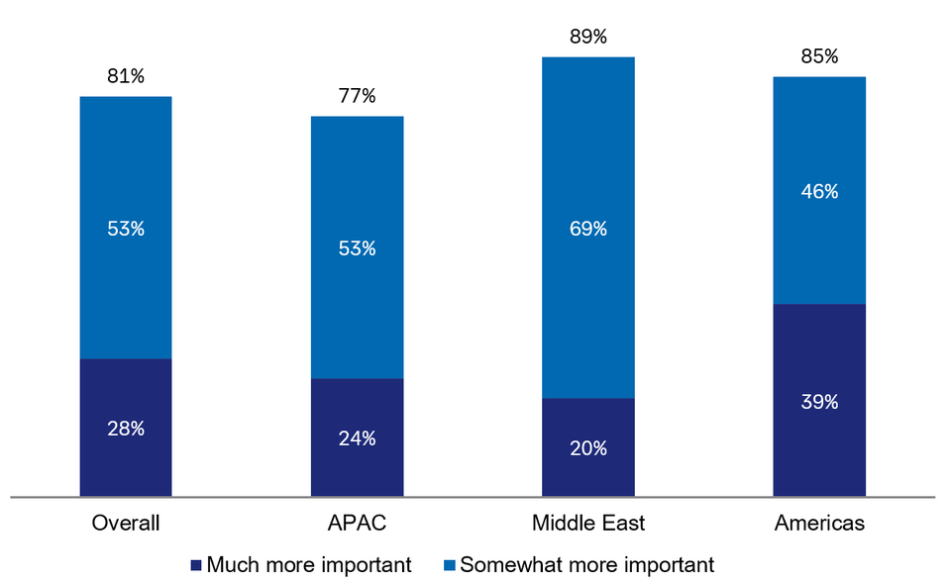
Source: Global Sentiment Survey on Europe 2026, B2B online survey. Base: n = 1,200 (APAC 600, Middle East 200, Americas 400)

A stable base in uncertain times
Resilience is a critical factor in today's environment, as geopolitical tensions and economic uncertainty increasingly influence investment decisions. Europe performs strongly on this dimension: around 71 percent of investors consider the region highly or rather resilient as a business location, while only about 10 percent view it as not resilient. This reinforces its attractiveness at a time when stability and predictability are especially important.
The regional breakdown provides additional insight. Resilience is rated most positively in the Middle East (82 percent), solidly in APAC (71 percent) and a little more cautiously in the Americas (65 percent). In all the other regions, too, a clear majority sees Europe as resilient.
Taken together, the findings in this chapter describe more than an attractive region. Europe is widely favoured, its appeal grows with investors’ experience, its importance is rising, and investors are confident it will stay stable under pressure.

Figure 4: Europe’s perceived resilience, by region
Top-2 Box of five-point scale (all respondents)
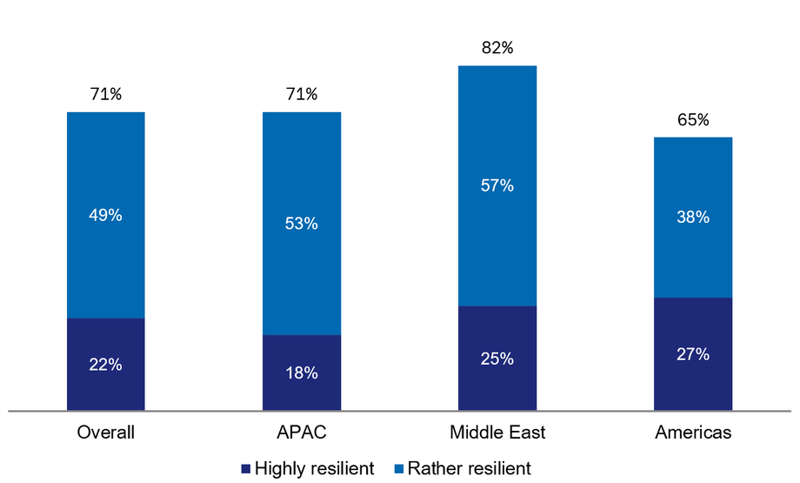

Source: Global Sentiment Survey on Europe 2026, B2B online survey. Base: n = 1,200 (APAC 600, Middle East 200, Americas 400)

Confidence in Europe is translating into investment plans
Europe's strong standing among investors is important, but the real measure of success is whether it influences actual investment behaviour. This chapter examines how positive sentiment translates into intentions to invest, expand and allocate resources. The results indicate that investor confidence is increasingly translating into investment plans.

At a glance
61%  are invested in Europe and plan to expand | 33%  are planning or considering market entry | 82%  of Americas-based firms are already invested in Europe

From confidence to concrete plans
Among the surveyed companies, 61 percent are already invested in Europe and plan to expand within five years. Only 6 percent are invested with no plans to expand. A further 33 percent of all respondents are not invested in Europe but are planning or actively considering market entry. The large majority are therefore either deepening their presence in Europe or preparing to establish one.
Investment intentions also vary by company size. Around three-quarters of companies with at least 500 employees are already invested in Europe, compared with roughly half of those with 100 to 249 employees. This suggests that medium-sized companies, in particular, still represent a significant source of potential future investment in Europe.

Figure 5: Current and planned investment in Europe
(All respondents)
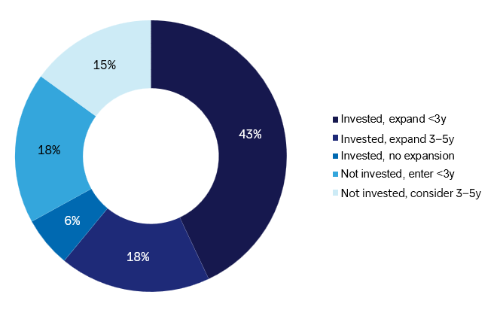

Source: Global Sentiment Survey on Europe 2026, B2B online survey. Base: all respondents, n = 1,200

Investment levels vary by region
The starting point for investing in Europe varies across regions. Companies from the Americas have the largest existing presence in Europe: 82 percent are already invested, compared with 74 percent in the Middle East.
With 55 percent already invested in Europe, APAC stands out for its future potential: the region has the largest share of companies planning to enter Europe.
Regional context matters when interpreting these findings, with different priorities across regions. In the Americas the focus is on strengthening engagement with the mature investor base, while in APAC it is on helping prospective investors turn their strong interest in Europe into concrete investments. Overall, the survey shows that companies already invested in Europe consistently rate the continent more favourably.
Figure 6: Currently invested in Europe, by region
(All respondents)
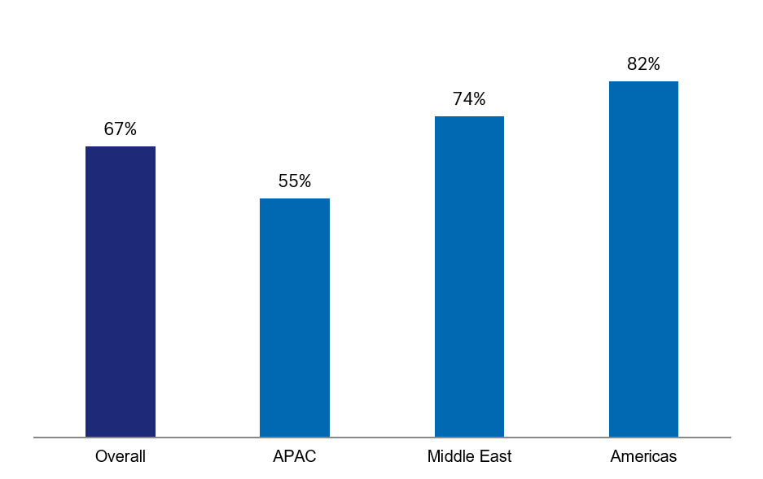
Source: Global Sentiment Survey on Europe 2026, B2B online survey. Base: n = 1,200 (APAC 600, Middle East 200, Americas 400)

Commercial reach outweighs local production
For now, most engagement is commercial rather than industrial. Europe is used first as a sales market: about 73 percent of invested firms sell into the region without any local presence, and 59 percent run their own sales or distribution teams there. Only 19 percent make goods in Europe, which shows that deeper, capital-intensive commitment is still the exception.
The depth of that commitment differs sharply by region. Firms based in the Middle East are mostly exporters, with 87 percent selling in Europe and just 3 percent producing locally. APAC investors lead on building their own European sales and distribution teams (78 percent), while investors from the Americas are the most likely to produce on the ground (28 percent).

Figure 7: Type of investment in Europe
Multiple answers possible (already in Europe invested)
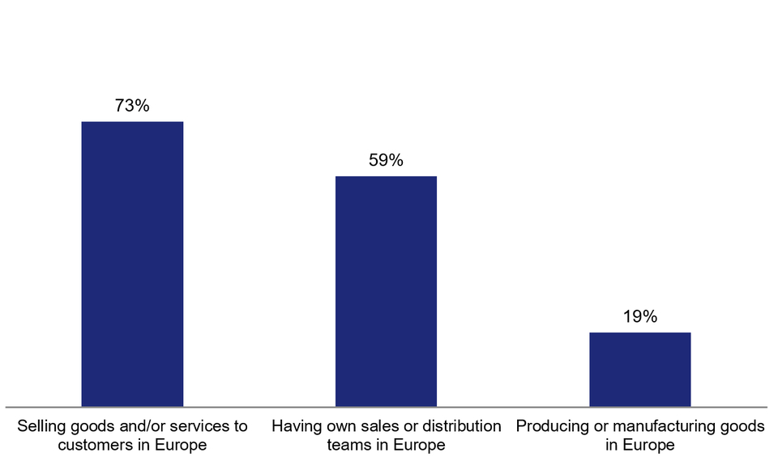
Source: Global Sentiment Survey on Europe 2026, B2B online survey. Base: all respondents, n = 807 already invested

A potential shift in global investment portfolios
One indication that the confidence revealed in this survey could translate into concrete investment into Europe comes from where the additional capital would be sourced. For many respondents, greater commitment to Europe would not be an add-on; it would mean rebalancing their global investment portfolios. North America is the most frequently named source of reallocated capital (41 percent), followed by APAC excluding China (36 percent) and the Middle East (28 percent). Only 20 percent say they would not shift investment from another region.
This is a clear sign that Europe’s appeal is growing relative to other regions.
Figure 8: Regions from which investors would shift capital towards Europe
Multiple answers possible (all respondents)
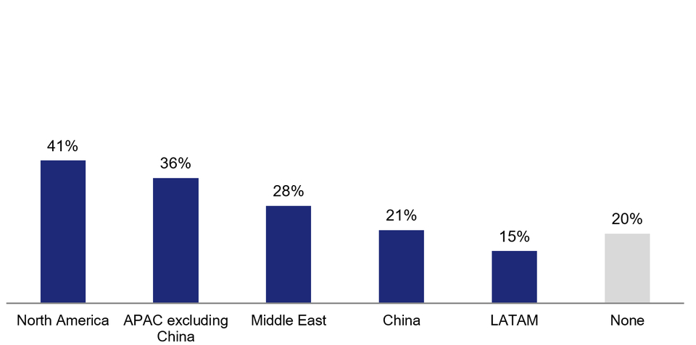

Source: Global Sentiment Survey on Europe 2026, B2B online survey. Base: all respondents, n = 1,200

Turning Europe’s strengths into action
Europe's resilience is an important part of its appeal, but investors do not see the region merely as a safe haven. The findings show that Europe is valued just as much for its growth potential, innovative capacity, industrial strength and ability to scale.
The question now is how Europe can make even better use of its existing strengths.
At a glance
74%  see growth opportunities as a clear advantage | 71%  see innovation and AI as a clear advantage | 99%  call Europe an important consumer market

Growth opportunities drive interest, stability builds confidence

Europe’s greatest strengths are all future-oriented. At the top are growth opportunities, innovative capacity, international relationships and economic stability. Between 68 and 74 percent of respondents consider each of these factors as a strong or moderate advantage; 25 to 32 percent even rate them highest. Europe’s appeal rests first on growth and innovation opportunities, with stability strengthening rather than defining the investment case.

Figure 9: Europe’s key strengths compared to other regions (All respondents)
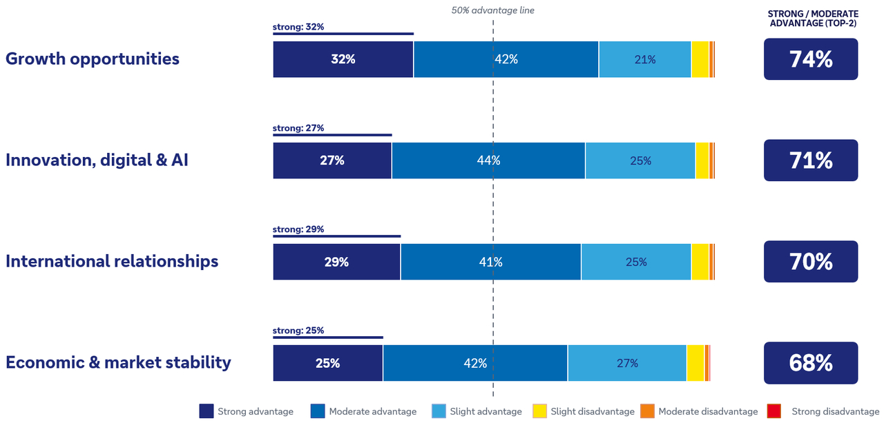
Source: Global Sentiment Survey on Europe 2026, B2B online survey. Base: all respondents, n = 1,200

Almost universally valued as a consumer market
On the demand side, the case is settled. Europe is valued almost universally as a consumer market: 99 percent of respondents rate it as important for their growth over the next three to five years, with 58 percent saying very important and a further 41 percent somewhat important. Europe's purchasing power – a large, wealthy and stable base of consumers – remains a first-order reason for international companies to be present.
Figure 10: Share of companies that see Europe as an important consumer market within the next five years
(All respondents)
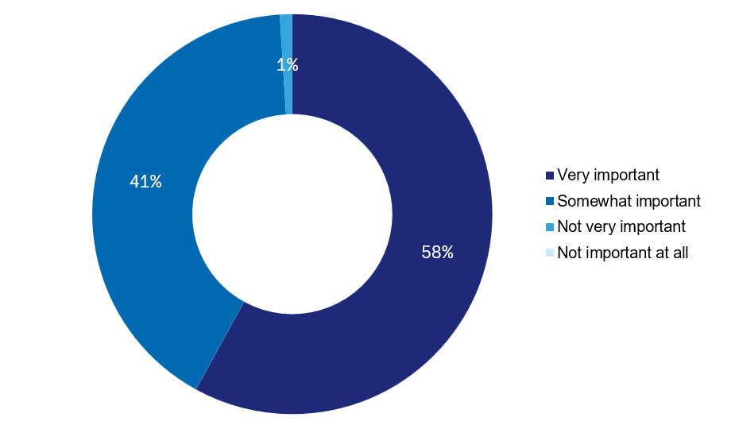

Source: Global Sentiment Survey on Europe 2026, B2B online survey. Base: all respondents, n = 1,200

Strong potential as a production location
Europe's appeal is not limited to demand. Although current investment is focused on the consumer market, more than nine in ten respondents (92 percent) also rate it an important location for production – for making goods, for research and development, and for supply chains – with 51 percent saying very important and 41 percent somewhat important. That is a strong endorsement of Europe’s industrial strength. Production is rated very important most often in the Middle East (68 percent).
Today, however, only 19 percent of respondents who are already active in Europe make goods there, so the strong commitment to Europe reflects intent more than current activity. The stated interest still has to translate into concrete investments. Even so, Europe is rated highly as a location for production and as a consumer market.

Figure 11: Share of companies that see Europe as an important production location within the next five years
(All respondents)
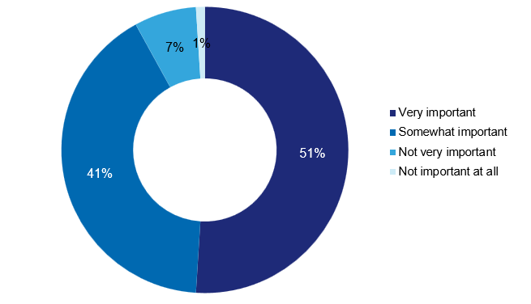
Source: Global Sentiment Survey on Europe 2026, B2B online survey. Base: all respondents, n = 1,200

Germany leads the European field
Europe's appeal is broad-based, but investment intentions are not evenly distributed across the region. Among potential destinations, Germany emerges as the focal point for future investment, ranking ahead of both the United Kingdom and France. Rather than competing with the wider European story, Germany reinforces it: the country's strong position highlights where many investors see the greatest opportunities within Europe's overall attractiveness.

At a glance
56%  include Germany in their Top 3 markets | 29%  rank Germany as their first choice | 3  leading markets: Germany, the UK and France

The leading planned investment destination
Germany is the anchor of European investment intent. Among companies with firm investment plans, 56 percent include Germany in their top three target markets, against 47 percent for the United Kingdom and 35 percent for France. Germany is also the most common single first choice (29 percent), ahead of the United Kingdom (23 percent) and France (9 percent).
Below the leading three, a clear second tier forms. The Netherlands, Italy and Spain cluster at around 20 to 22 percent Top-3 consideration, with Switzerland, Poland and Portugal further back. While investors see opportunities across Europe, Germany, the United Kingdom and France remain the three markets at the centre of most investors’ shortlists.
Figure 12: Planned investment countries in Europe
Country named in their Top 3 or as first choice (all respondents)
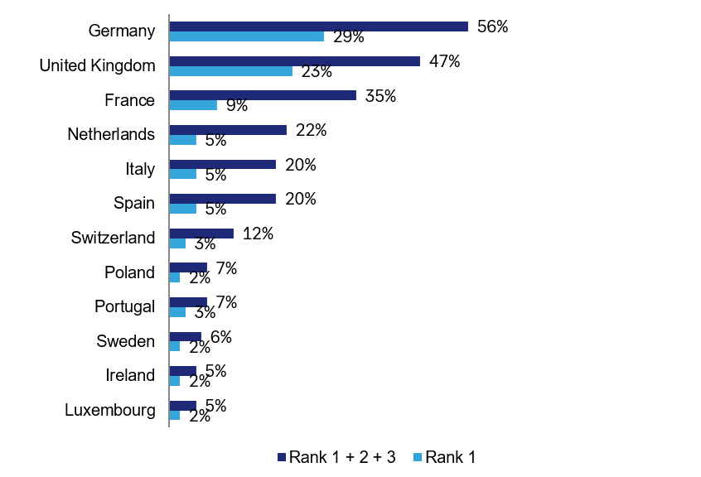
Source: Global Sentiment Survey on Europe 2026, B2B online survey. Base: all respondents, n = 1,200

Strength through breadth
Germany's advantage rests on breadth rather than on any single decisive strength. It stands, above all, for structural substance: it leads on infrastructure and logistics (59 percent), on innovation and AI (58 percent), and on both industrial capability and skilled workforce (56 percent each). All other scores are between 48 and 59 percent.
Figure 13: Strengths of top 3 investment destinations by factor
Germany, the UK and France (all respondents)
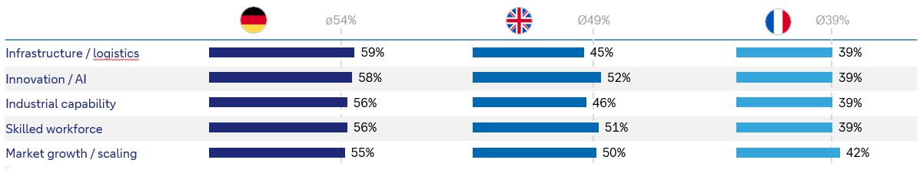
Source: Global Sentiment Survey on Europe 2026, B2B online survey. Base: all respondents, n = 1,200

Priorities for action in Europe
Four factors fall below the 50 percent advantage line. These are Europe's clearest priorities for action: labour cost competitiveness (42 percent), the tax and incentive environment (44 percent), energy cost competitiveness (47 percent) as well as approval and permitting speed (47 percent).
The result is a clear agenda. Europe's stability provides a strong basis for long-term investment, but it is no substitute for reform.
Figure 14: The four priorities for action where Europe can strengthen its competitiveness
(All respondents)
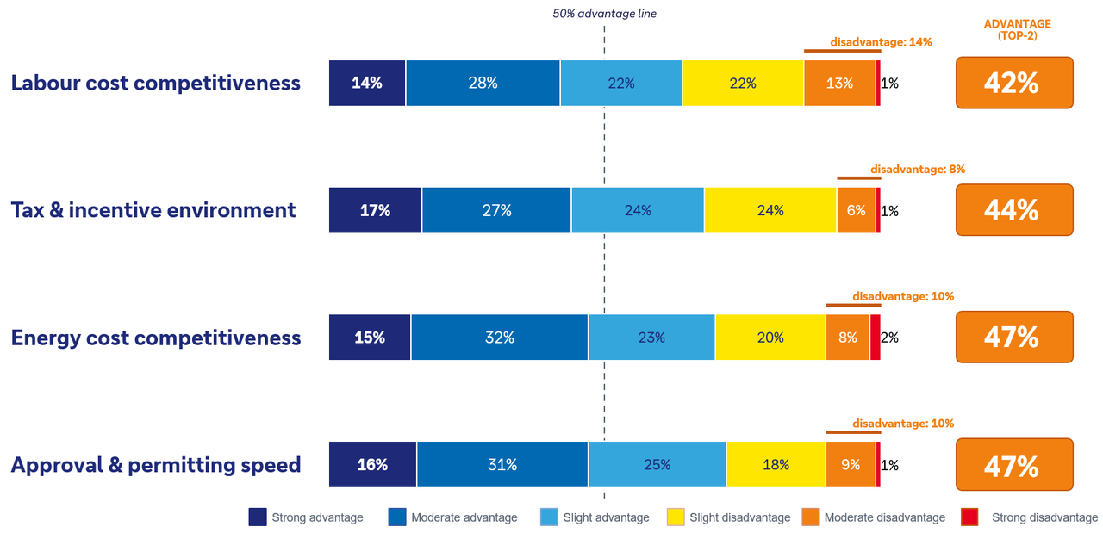

Source: Global Sentiment Survey on Europe 2026, B2B online survey. Base: all respondents, n = 1,200

Europe has yet to realise the full benefits of the Single Market
Investors value Europe, but they do not yet experience it as a single, seamless market. This chapter sets out how unified the region is seen to be, and how much cross-border friction still weighs on its appeal. The message is clear: Europe's biggest obstacle is Europe itself.

At a glance
62%  see a unified or mostly unified market | 43%  report large or very large friction | 20%  experience Europe as fully unified

A single market that is not yet seamless
The verdict on integration is positive but qualified. On a four-point scale, 20 percent of respondents see Europe as a unified market, and a further 42 percent see it as mostly unified. On the other side, 30 percent see Europe as mostly fragmented and 8 percent as fully fragmented. The promise of the single market is clearly visible; seamless delivery is not.
Perceptions of European unity are strongest in the Americas, where 69 percent view the region as unified or mostly unified. In the Middle East, the share is 60 percent and, in APAC, 58 percent. No region sees Europe as fully seamless, and the pattern holds across company sizes and investment stages. The implication is clear: completing the single market would not create Europe's appeal from scratch; it would unlock appeal that already exists but remains constrained by lingering barriers.
Figure 15: Europe viewed as a unified or fragmented market
Four-point scale (all respondents)
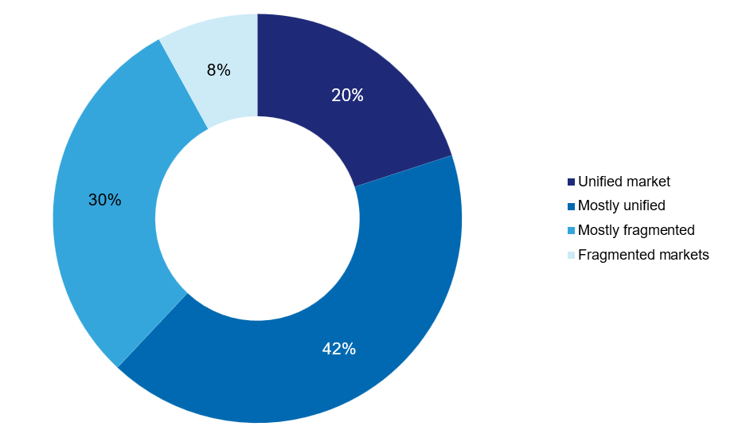

Source: Global Sentiment Survey on Europe 2026, B2B online survey. Base: all respondents, n = 1,200

Figure 16: Europe viewed as a unified or fragmented market by region
(All respondents)
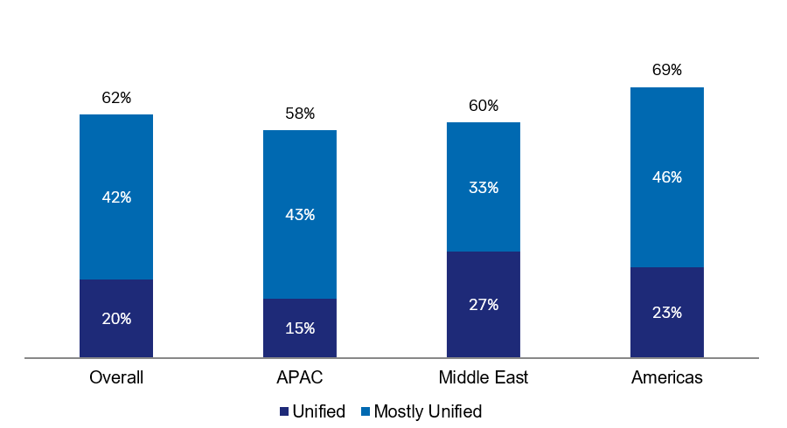
Source: Global Sentiment Survey on Europe 2026, B2B online survey. Base: n = 1,200 (APAC 600, Middle East 200, Americas 400)

Cross-border frictions weaken investment appeal
Europe’s investment strengths are clear, but cross-border frictions continue to limit their full impact. 43 percent of all respondents say cross-border frictions reduce Europe's attractiveness to a large or very large extent, a further 42 percent to some extent, and only around 15 percent see little or no impact. In total, about 85 percent feel at least some friction. Taken together, these cross-border frictions are the biggest obstacle to Europe's attractiveness.
The burden is very unevenly felt. It is greatest in the Middle East, where 86 percent report a large or very large impact, followed by the Americas at 49 percent, and in APAC at about 26 percent. The Middle East responses show that Europe has many strengths but needs to work on improving the basic framework: the region is the most enthusiastic about Europe but at the same time the most critical on friction.
Figure 17: Extent to which cross-border frictions reduce Europe's attractiveness
(All respondents)
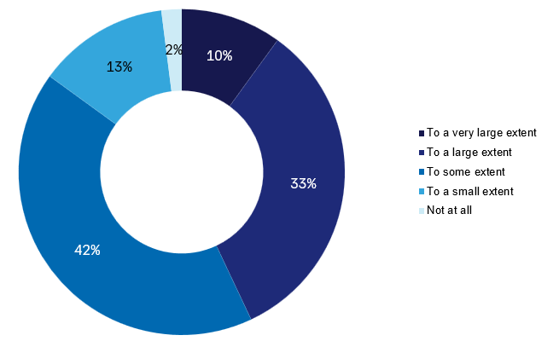

Source: Global Sentiment Survey on Europe 2026, B2B online survey. Base: all respondents, n = 1,200
Figure 18: Extent to which cross-border frictions reduce Europe's attractiveness, by region
(All respondents)
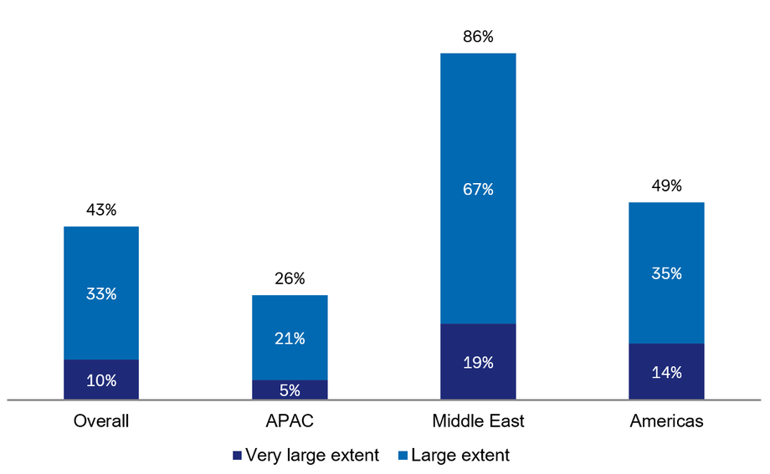

Source: Global Sentiment Survey on Europe 2026, B2B online survey. Base: n = 1,200

Europe can strengthen its AI competitiveness
Artificial intelligence is one of the most important technologies shaping future investment decisions. Investors are clear in their view that Europe should play a leading role in the AI economy, and they are equally clear about what is needed to make that happen. Their priorities are closely aligned, with the strongest emphasis on a simpler and more harmonised regulatory framework. The message is straightforward: investors see significant potential in Europe’s AI future but unlocking it will require an environment that makes innovation easier to develop, scale and deploy across the region.

At a glance
33%  want simpler AI regulation and frameworks | 31%  want upgraded technological infrastructure | 28%  want better access to AI growth capital

Progress needed across the AI ecosystem
Asked how Europe could become more attractive for investment, innovation and the use of AI, investors cite simpler AI regulation and frameworks first at 33 percent, followed by upgrading technological infrastructure (31 percent), strengthening digital skills and creating competitive technology incentives (both 29 percent) and improving access to AI growth capital (28 percent).
Figure 19: Measures to improve Europe's AI attractiveness
Select the three most important measures (all respondents)
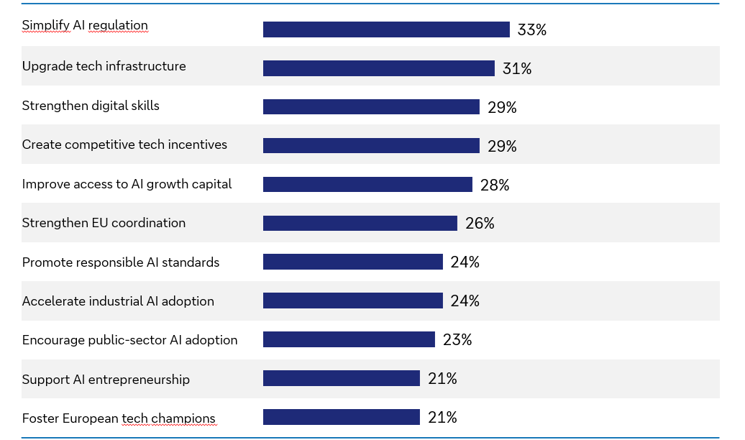

Source: Global Sentiment Survey on Europe 2026, B2B online survey. Base: all respondents, n = 1,200

The core finding here is that investors expect Europe to improve in several areas at once. Viewed as a whole, the eleven measures form a clear roadmap for Europe to improve its competitiveness in terms of AI.
First is the need for less friction by means of a simpler, more harmonised regulatory environment, supported by stronger EU-level coordination and trusted standards for responsible AI. Second, the need to build capacity to make sure the computing power, capital and talent needed to compete are actually in place in Europe. And third, Europe needs to generate demand, for example by means of competitive tax and incentive frameworks, faster adoption in industry and the public sector, support for AI start-ups, and room for European champions to grow.

European banks are well placed to support investment
As investors translate confidence in Europe into concrete investment decisions, the choice of financial partner becomes increasingly important. Here, international companies consistently hold European banks in high regard. Their decisions are guided less by cost considerations and more by the qualities that matter most when managing complex cross-border investments: financial stability, strong compliance capabilities and local market expertise. Together, these factors create a meaningful home-market advantage for European banks and help explain their prominent role in supporting international investment across the region.

At a glance
60%  prefer a European banking partner | 97%  preference in the Middle East | 37%  prioritise financial strength

A clear preference for European banking partners
60 percent of respondents say they would prefer to work with a European bank when investing in Europe. Proximity and substance count for more than price, which is a structural advantage for European banks on their home ground.
The preference is strongest where the appetite for Europe is greatest. It reaches 97 percent in the Middle East. In the Americas the reported preference level is at 57 percent, in Asia-Pacific at 49 percent.

Figure 20: Preferred origin of banking partner when investing in Europe
(All respondents)
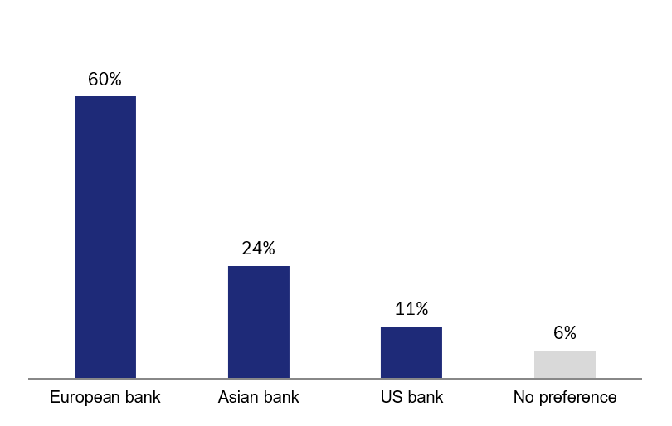
Source: Global Sentiment Survey on Europe 2026, B2B online survey. Base: all respondents, n = 1,200

Strength, expertise and local knowledge matter most
The mandate is won mainly on trust and expertise. The bank of choice combines financial strength (37 percent), strong risk and compliance capabilities (36 percent) and local market and regulatory expertise (33 percent). Closely behind is the quality of the digital banking platform (31 percent). Broad European presence and deep product capabilities follow (both 30 percent), while competitive pricing (26 percent) and an existing banking relationship (19 percent) come lower down the list.
That order is worth reading carefully. A competitive price is always relevant, and in the end economic value is part of every decision. But price is not the main factor investors name when choosing a bank; what counts most is trust, expertise and the ability to deliver. That is the ground on which established European banks compete best – a clear opportunity to turn global confidence in Europe into lasting client relationships.
Figure 21: Most important criteria when choosing a banking partner for Europe
Select the three most important (all respondents)
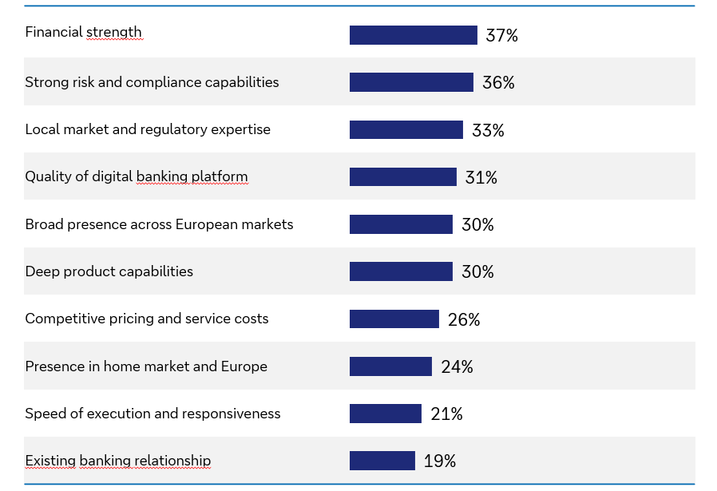

Source: Global Sentiment Survey on Europe 2026, B2B online survey. Base: all respondents, n = 1,200

Summary: What the results mean for Europe
The findings throughout this report point to a consistent conclusion: investors see Europe as a region of opportunities. Its attractiveness is broad-based, its relevance is increasing, and confidence is already being reflected in investment intentions. The opportunity now is to convert that confidence into tangible economic outcomes through greater market integration, regulatory simplification and a stronger environment for innovation.
The message is both encouraging and actionable. Europe already benefits from powerful strengths, including innovation, growth potential, resilience and international reach. The focus now is on removing the practical barriers that continue to hold investment back, particularly around costs, regulation, market integration and AI governance. Because these concerns relate to the business environment rather than to Europe’s underlying attractiveness, they can be addressed.
For European banks, the message is clear. International investors prefer partners that combine financial strength, trusted risk and compliance expertise, and deep local market knowledge. Because these factors matter more than price alone, European banks benefit from a meaningful competitive advantage. Banks therefore have a critical role to play. They must work closely with and advise investors to help turn international interest in Europe into investment, growth and long-term prosperity.

